
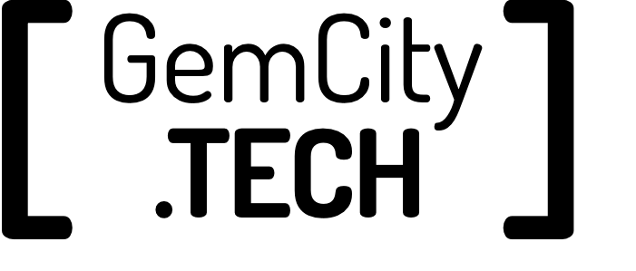
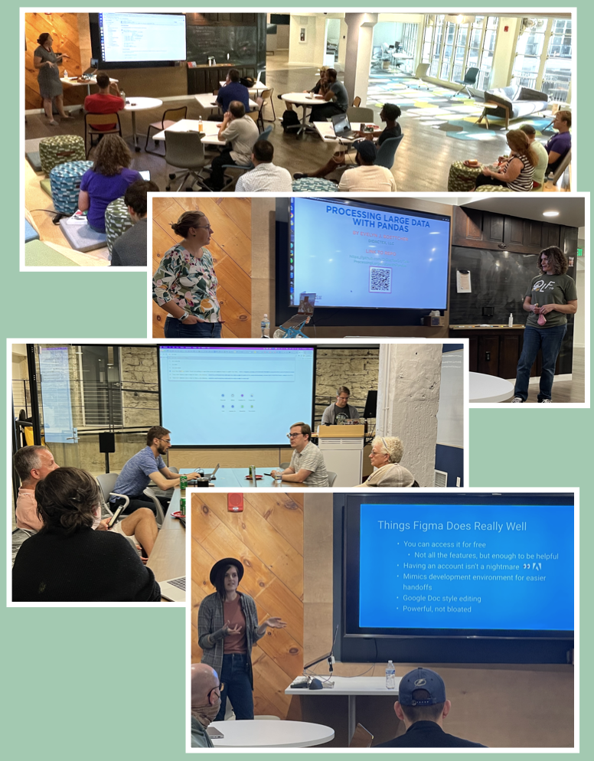
You should join us at the next GemCity TECH event if you want to:
- Deepen your knowledge in a technology discipline
- Grow your skills, diversify your skills or get your feet wet in a topic of interest
- Expand your network of technology professionals
- Find like minded people to collaborate on your project
- Deepen your technology knowledge by sharing it at an upcoming event
- Speak to GemCity TECH leaders about starting your own community in the GemCity TECH family
- Grow local industry by sponsoring GemCity TECH
Our partner, the Arcade’s Innovation Hub, offers a variety of meeting spaces for our groups.
The Arcade is a historic complex located in Dayton's central business district. It features elegant architecture with grand and open spaces.

Join us for one of our next meetings and we’ll give you a tour of this beautiful collaboration space.
For more information on The Hub visit:
https://TheHubDayton.com
Where do we meet?
Serving the technical user community
Growing user communities by providing a centralized destination for technical training, workshops, forums and opportunities to collaborate.
For more information on GemCity TECH visit:
https://GemCity.TECH


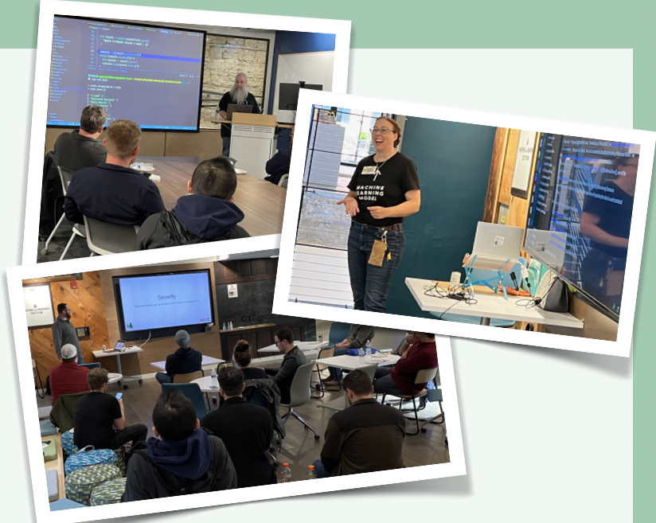
Why User Groups Are Important?
Each of our monthly user groups brings people together to explore and learning about technology. We provide a platform for people to get involved, exercise new skills make new friends and build a support system.
There are multiple opportunities to share your knowledge, learn from others and take ownership of your own community.
How Can You Help?
We are always looking for sponsors to support our efforts. We always need support providing refreshments and resources. More importantly, we need the talented people from your organization to join us, share their knowledge and evangelize our efforts.
Multiple Opportunities Every Month
We currently have 10 groups that meet each month offering multiple opportunities for you to to get involved. All are free and we welcome anyone who has interest in tech discussions.
All meetings are at the Innovation Hub in the newly restored downtown Dayton Arcade.
Code For Dayton A monthly user group meeting that follows the “hack night” format.
Organizer: David Best
Meeting Day:
1st Tuesday of the month
New to Tech - A public group targeted at folks who are just starting to learn about software development, up through who are targeting their first promotion.
Organizer: Matt Alioto
Meeting Day:
1st Tuesday of the month
Dayton Web Developers - general topics around being a modern web developer. From starting a career as a web developer to using the latest technology.
Organizer: Allen May
Meeting Day:
1st Wednesday of the month
Dayton Dynamic Languages - Casual discussions and demonstrations that lean towards Ruby/Rails, Python/Django, Scheme, Lisp & Smalltalk
Organizer: Catherine Devlin
Meeting Day:
2nd Wednesday of the month
Gem City Game Developers - All topics around gaming, the gaming industry, design, art, programming, digital and non-digital game topics.
Organizer: Bryan Turner
Meeting Day:
2nd Thursday of the month
Dayton .NET Developers - Helping software developers, technical leads, and managers keep in touch with .NET-related technologies.
Organizer: Hanen Alkhafaji
Meeting Day:
2nd Thursday of the month
Frameworks A monthly meeting that explore a balance of both frontend web DESIGN topics & frontend web DEVELOPMENT topics.
Organizer: Allen May
Meeting Day:
3rd Wednesday of the month
Gem City Machine Learning For professionals who are curious about machine learning and meeting with like minded professionals.
Organizer: Evelyn Boettcher
Meeting Day:
3rd Thursday of the month
Gem City Mechatronics Electronics enthusiasts meeting for informative presentations, workshops, and hands-on lab sessions on topics like electronics, prototyping, circuitry, Raspberry Pi and Arduino projects.
Organizer: Vibes
Meeting Day:
2 nights a month
Autonomous Miami Valley Promoting and advancing the use of autonomous technologies for researchers, developers, engineers, entrepreneurs, policymakers, and implementers of autonomous systems.
Organizer: Robert Orenbaun
Meeting Day:
2nd Tuesday of the month

